Piniagin Maxim

Task 1

No optimisation:

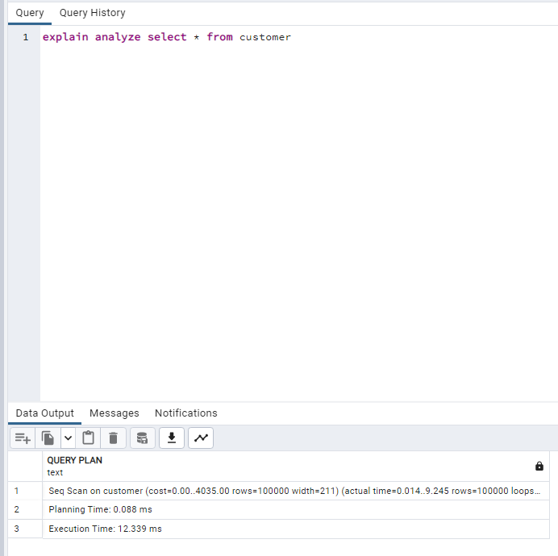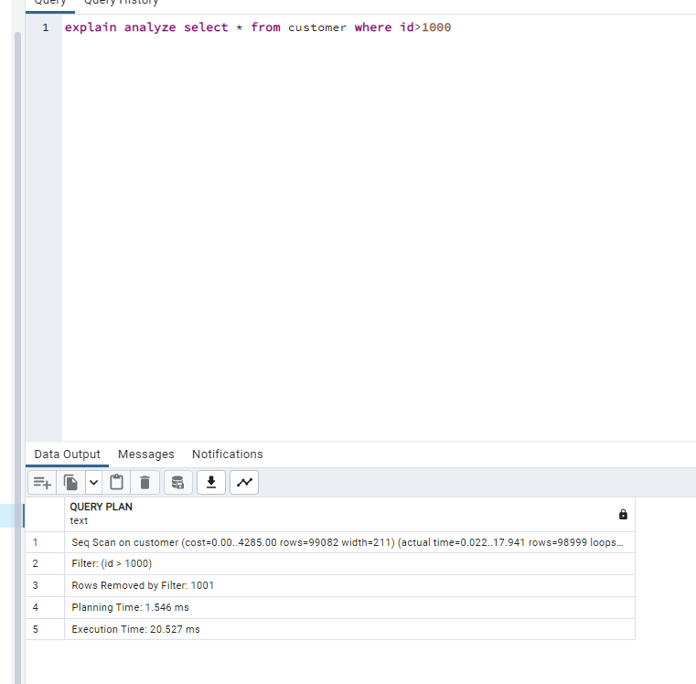

Btree indexing:

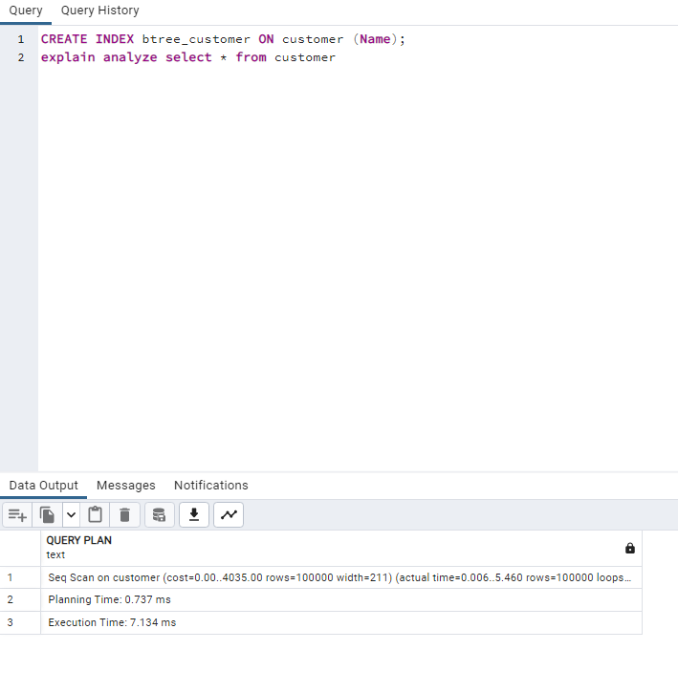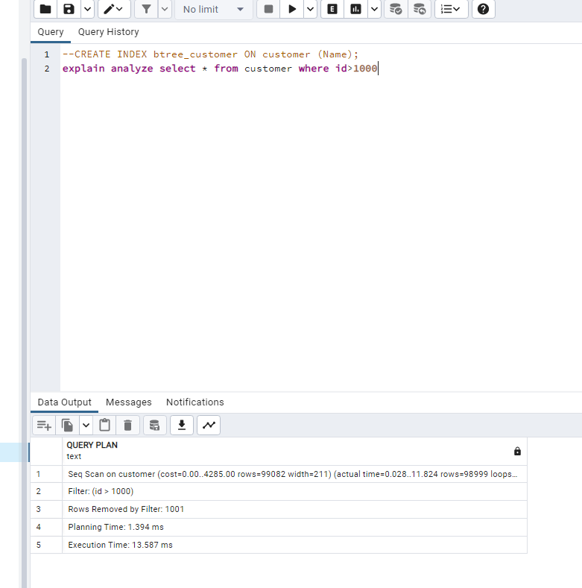

Hash indexing:

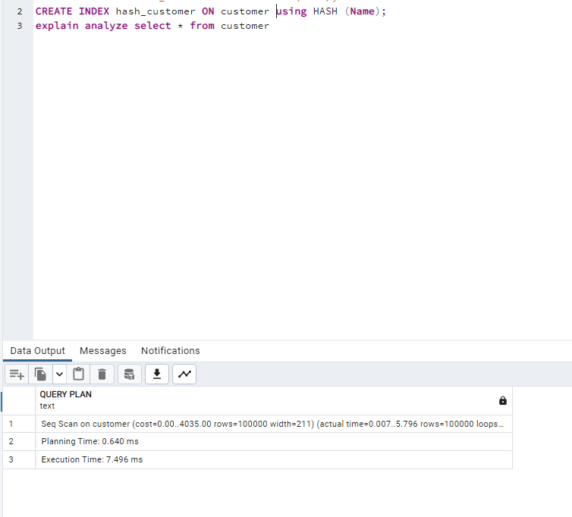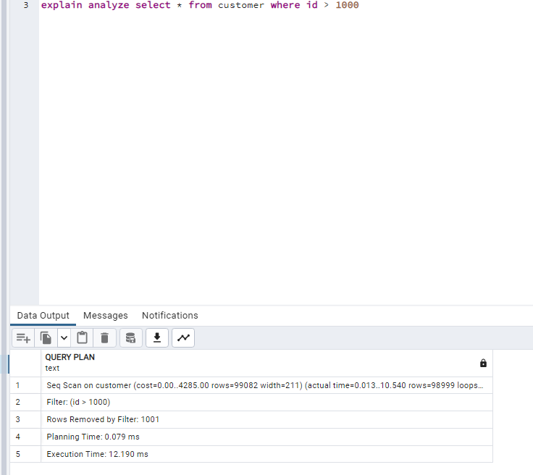

Conclusion: I used a database of 100000 entries to see differences in performance and the result is that no indexing has the worst performance and Btree has the best one.

Task 2

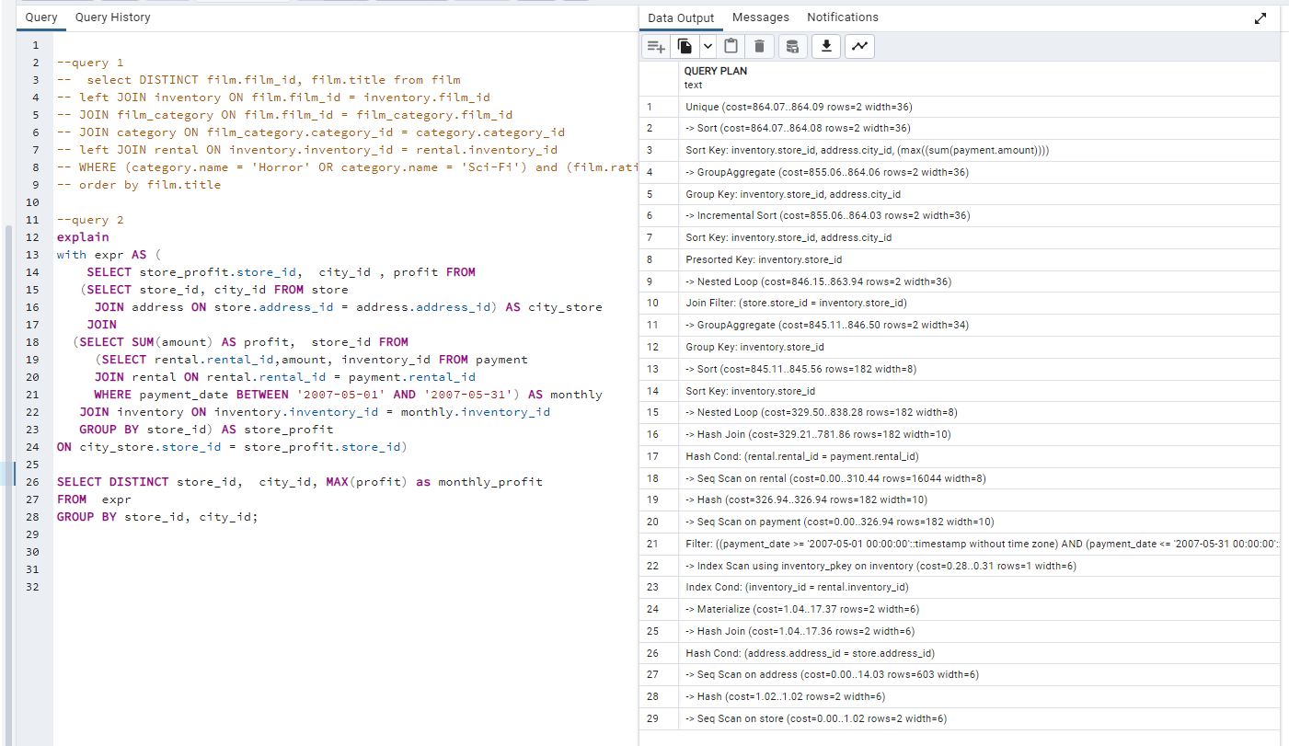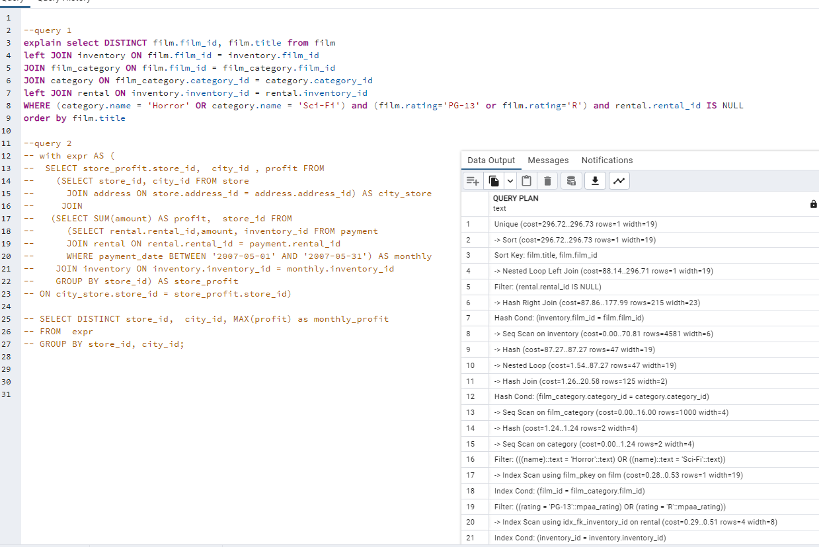

For the first query the most expensive step is sorting by film.title, film.film_id, and for the second one is sorting by inventory.store_id, address.city_id, (max((sum(payment.amount)))).

Both can be optimized by using btree indexation.

(SQL queries code is in the attached .sql file)